# **CHAPTER 1: Introduction**

## **1.1 Introduction**

The entertainment industry has undergone a tremendous transformation in today's fast-paced and digital era. The days of impatiently waiting outside the cinema to buy a ticket for the newest movies are long gone. How we view and access movies has changed since the arrival of technology. One such innovation that has transformed the experience of watching movies is the Movie Ticket Booking System.

The Movie Ticket Booking System is a web-based application designed to streamline the process of reserving and purchasing movie tickets. With just a few clicks, movie enthusiasts can effortlessly secure their seats for a desired showtime and choose preferred seats from the comfort of their homes. The main goal of the Movie Ticket Booking System is to eliminate the inconveniences associated with traditional ticketing methods. With this system, users can browse several movies, view show timings, and select seats, avoiding long queues. Moreover, the system provides real-time updates on seat availability, enabling users to make informed decisions and plan their movies effortlessly. By simplifying the ticket booking process, our system will save time and ultimately redefine the movie-going experience for audiences.

# **1.2 Problem Statement**

* Purchasing movie tickets by standing in queues consumes significant time.
* Customers are unable to preselect their seats in advance.
* Customers are unaware of the movie showtime.

## **1.3 Objective**

* To enable customers to purchase movie tickets along with their favorable showtime.
* To allow customers to select seats of their choice.

## **1.4 Scope and Limitations**

**Scope**

Our system is concerned with effortlessly browsing a diverse catalog of movies, selecting preferred showtimes, and completing online payments for booked seats. The system’s design will be flexible, enabling future expansion and integration of more theatres.

**Limitation**

The significant limitation of our system is the reliance on a single theatre for showing movies. Moreover, there is no feature of reserve now and pay later.

## **1.5 Report Organization**

Chapter One: This chapter introduces the system and the problems, and gives an overview of the study.

Chapter Two: This chapter covers the literature review which is the previous related work that has been done before.

Chapter Three: This chapter explains the selected methodology that we are going for in this project and planning through the methodology.

Chapter Four: This chapter discusses the implementation and testing

.Chapter Five: This chapter discusses the conclusion, recommendations, and future works to improve this study

# **Chapter 2: Background and Literature Review**

## **2.1 Background Study**

In a rapidly evolving entertainment landscape characterized by the rise of digital streaming platforms, movie ticket booking systems have emerged as a key innovation. This web application meets the need for changing movie viewing habits by providing users with a seamless and convenient solution to book and purchase movie tickets. It aims to eliminate the frustrations associated with traditional ticketing methods, by providing a user-friendly platform where moviegoers can easily explore a diverse collection of movies, choose show times, and get priority seating while avoiding the hassle of long lines. Movie ticket booking systems represent an important step towards improving the moviegoing journey of audiences.

## **2.2 Literature Review**

**GPRS-Based Cinema Ticket Reservation System by Mihai Balan**

This study was conducted in 2013. According to the literature [1], This service is called Cinema Ticket Reservation System and it can determine a user`s current position, allow users to search for movies in a given range from their current position, or reserve/purchase tickets. Users can pay for tickets using credit cards saved in a secure wallet embedded into the application, or e-money received as a refund for the canceled tickets. Workshops and interviews are conducted with real users to build and evaluate different low and high-fidelity prototypes. This proof-of-concept prototype shows how a user-centered approach can drive a web service's design and implementation phases, and how several technologies can be merged to create a successful service.

Identified Issues in the Cinema Ticket Reservation System Mobile Device Limitations

* MIDlet: UI design for a CLDC 1.1/MIDP 2.0-based mobile device; build rich and user-friendly UI; prevent UI lock-up during the network operations; make the information easy to read on a small screen; overcome the limited input capabilities.
* User-Centered Design of the Prototype: involve users in all steps of the system
* Location-aware MIDlet: determine the user’s current position; retrieve a list of all cinemas and movies in a certain range from the user’s current position; hardware and software necessary for a location-aware application.

Solutions to the Identified issues :

* **Mobile Device Limitations**

This can be achieved through good design of applications and communication protocols, use of lightweight libraries, and optimization of the packaging process (e.g. including only the parts of the library that are applied use and take advantage of source code obfuscation to replace long class names and variable names).

The small display problem can be overcome by using the One Screen at a Time method, i.e. long operations should be divided into small parts.

* **MIDlet**

Rich UI can be developed by taking advantage of both low-level and high-level components in CLDC 1.1/MIDP 2.0. One must prevent the UI lock-up during network operations by using background threads for that.

* **Location-aware application**

This is a location-aware application that can determine a user`s current position and display a list of all cinemas and movies in a certain range from that position. Based on the GPS data and application setup, all cinemas in the user`s range can be found.

**Contributions to the Security and Privacy of Electronic Ticketing Systems by Arnau Vives-Guasch**

This study was conducted in 2013. According to the literature [2], the use of information and communication technology (ICT) continues to grow in our daily activities, gradually replacing traditional paper systems with equivalent digital means, such as e-tickets. E-tickets represent a digital contract between two parties: the user and the service provider, summarizing their agreement so that the user receives a specific service from the provider. However, security is not the only concern; User privacy is also important in these systems. In the presented article, the author presents the main components involved in the electronic ticketing system:

* User : Receive e-ticket and submit for verification to access the service.
* Publisher : Responsible for creating and providing e-tickets to users.
* Service provider : Receive and confirm user’s e-tickets

**Dynamic Pricing in Movies Tickets Using Regression Technique by Vaibhav Gupta**

This study was conducted in 2018. According to this literature [3], The products have a limited and fixed selling season time and they are time sensitive. Like in the case of the airline industry, reservation of seats is permitted some months before the actual departure time, similarly, movie tickets are available online for pre-booking which lasts till the show time. Second, there is an amount of some fixed stock of products kept at the beginning of the sale which has to be sold during a particular season; hence no new product inventory is added over time. In the airline industry, the total number of seats in a particular flight is fixed and there will be no options for an extra new reservation for seats similarly for a movie show the number of seats available is fixed. For example, the price can be changed dynamically for a movie when it is online. According to the time horizon structure, three types of models are followed by all the problems:

1. Continuous time horizon, here cost can be changed at any time. In such type of cases, the time horizon is said to be discretized continuously.
2. Discrete time horizon, time is divided into several time intervals such that prices can be changed only at the initial stage of the period. A discrete horizon is suitable in those applications where price changes may cause a significant cost and prices are changed regularly depending on some fixed schedule (e.g. g. most of the physical stores shopping).
3. Customer based time horizon, The price is altered only in condition of the customer's arrival, and therefore it is dependent on the customer's arrival.

# **Chapter 3: System Analysis and Design**

## **System Analysis**

System analysis is the process of obtaining and evaluating data, diagnosing issues, and information about the movie ticket booking system. The system users and system developers must communicate extensively during this problem-solving process.

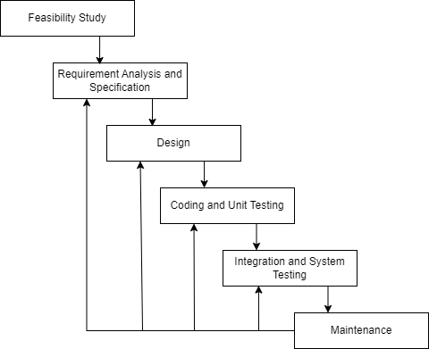

**Fig 3.1: Iterative Waterfall Model**

In this model, you can start with some of the software specifications and develop the first version of the software. After the first version if there is a need to change the software, then a new version of the software is created with a new iteration.

1. **Feasibility Study**

We assess our project's technical, operational, and economic aspects throughout this phase. We assess whether the system is a good and affordable option for fulfilling the project's requirements.

1. **Requirement Analysis and Specification**

In this phase, we analyze different functionalities like movie selection, and seat booking while acknowledging the primary focus on single theatre.

1. **Design**

We collect requirements outlining user expectations at the start of each iteration. These requirements form the basis for this particular phase. Users and administrators actively participate in evaluating the features that have been introduced and offering feedback. Subsequent iterations alter this feedback.

1. **Coding and Unit Testing**

We convert the provided criteria into functional code in this phase. A unit test is then performed to confirm that each component is functioning as expected. The iterative model enables us to review and improve the code and unit tests in response to feedback that is gathered at the end of each cycle.

1. **Integration and System Testing**

In this phase, these integrated elements are systematically tested to ensure that they function as a unified system. Given the iterative nature, this phase occurs multiple times, allowing for continuous refinement. During system testing, the entire system is assessed for compliance with the defined requirements and functionality.

1. **Maintenance**

This phase begins once the system has been deployed and is operational. The iterative nature of this model facilitates ongoing improvements and refinements in response to evolving user needs.

## **Requirement Analysis**

### **Functional Requirements**

* Customers can login with valid credentials.
* The system enables users to browse movies, pick a showtime, and book their preferred seat.
* The system will maintain a record of all the bookings made by the users.

**Use Case Diagram**

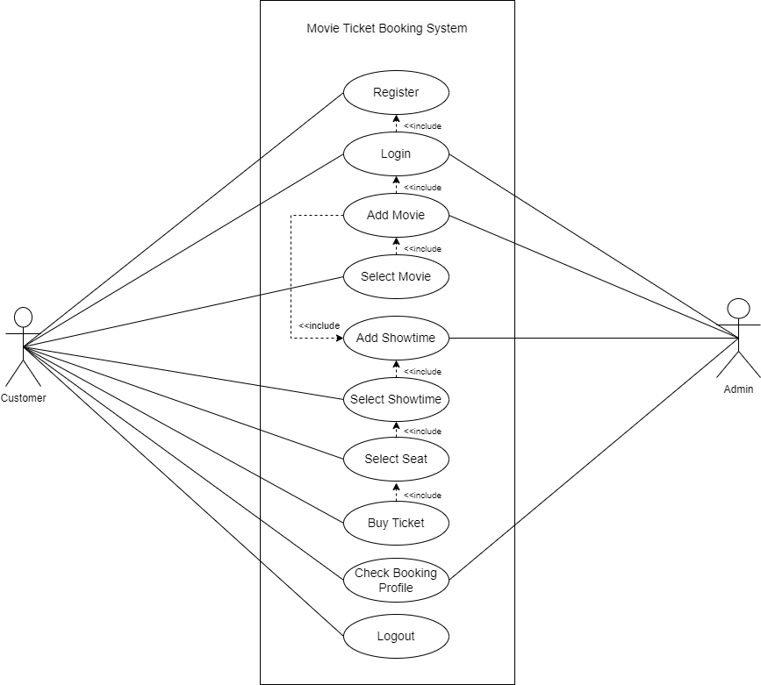

Fig: 3.2 Use Case Diagram

## **Non-Functional Requirements**

* **Security**

Users can only log in to the system with a valid login and password. The password and content of a user's profile can only be modified by that user.

* **Usability**

The system is straightforward to use and is easy to understand. It is user-friendly.

* **Performance**

The system can handle and support multiple users at a time.

## **Feasibility Study**

**Technical**

The system was developed using HTML, PHP, CSS, and Javascript, which were all sufficient to meet the needs. To keep all the customer records, a database is needed. This system will have a simple GUI and won't require much training.

**Economic**

The system was created entirely from free resources; no outside purchases were necessary. Additionally, since it is a computerized system and hence does not require additional staff, this method will reduce human efforts. The system will therefore be financially viable.

**Operational**

The system’s simple UI makes it easier to use. Customers can easily navigate the system and order tickets. It facilitates presenting movie details, showtime, and seat availability effectively.

**Schedule**

It is the measure of how reasonable the project timetable is or whether the deadline is reasonable or not. If the lack of time or the time becomes mandatory, we must finish the project within a given period. It mainly addresses:

**Gantt Chart**

|  |  |  |  |  |  |  |  |  |  |
| --- | --- | --- | --- | --- | --- | --- | --- | --- | --- |
| **Weeks Work** | **1** | **2** | **3** | **4** | **5** | **6** | **7** | **8** | **9** |
| **Planning** |  |  |  |  |  |  |  |  |  |
| **Analysis** |  |  |  |  |  |  |  |  |  |
| **Data**  **Modelling** |  |  |  |  |  |  |  |  |  |
| **Process Modelling** |  |  |  |  |  |  |  |  |  |
| **Database Implementation** |  |  |  |  |  |  |  |  |  |
| **Coding** |  |  |  |  |  |  |  |  |  |
| **Testing** |  |  |  |  |  |  |  |  |  |
| **Documentation** |  |  |  |  |  |  |  |  |  |

Fig 3.3: Gantt Chart

## **Data Modeling**

* + - 1. **ER Diagram**

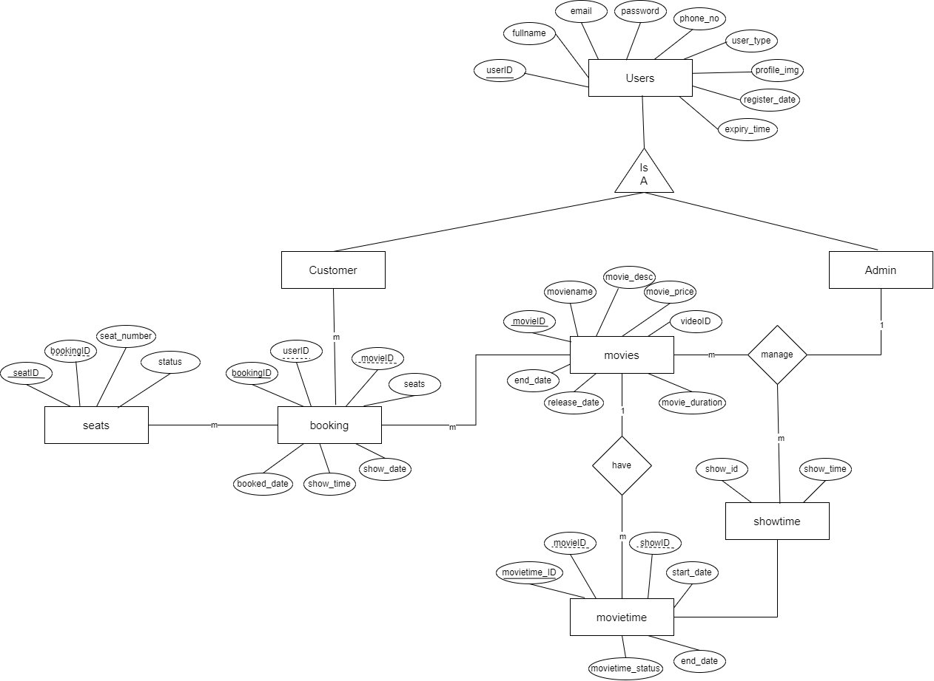

Fig: 3.4 ER Diagram

## **Process Modeling**

**3.1.4.1 Context Diagram**

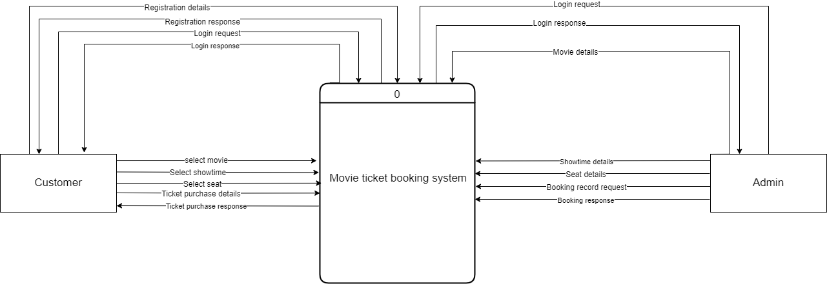

Fig: 3.5 Context Diagram

**3.1.4.2 Level 0 DFD**

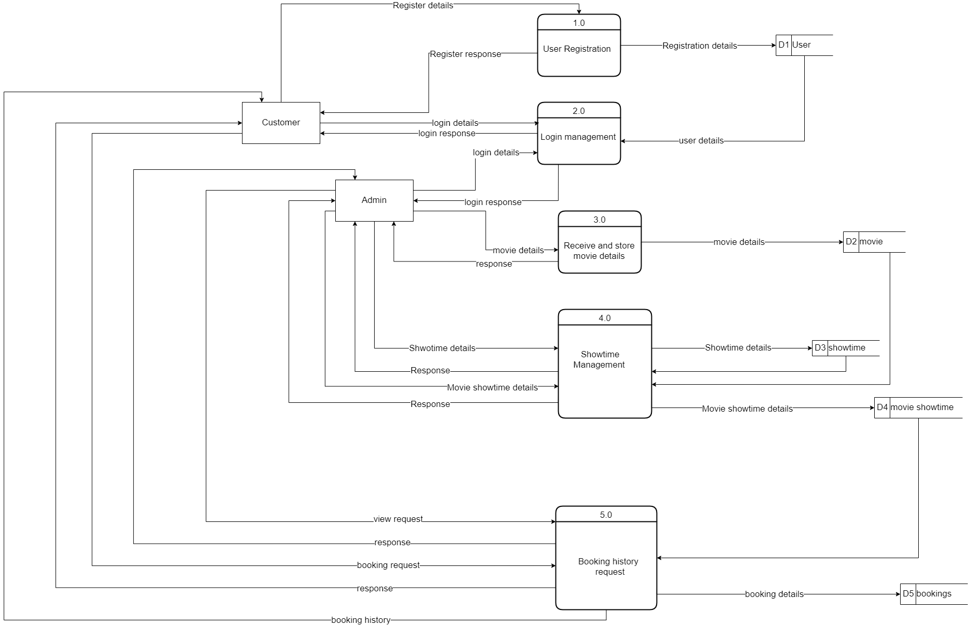

Fig: 3.6 Level 0 DFD

**3.1.4.2 Level 0 DFD**

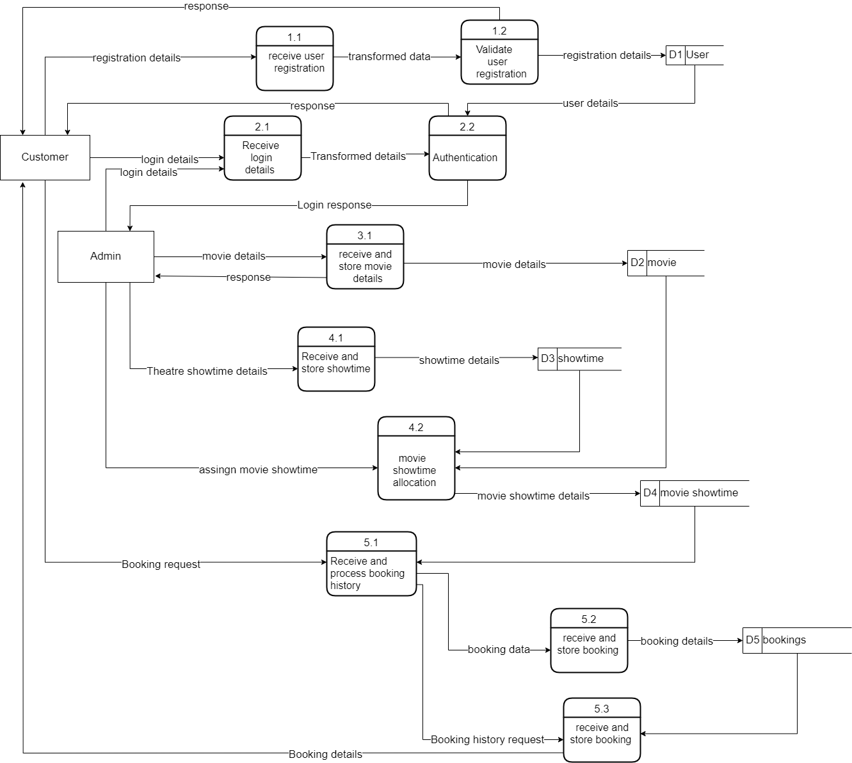

Fig 3.7 Level 1 DFD

## **System Design**

### **3.2.1 Architecture Design**

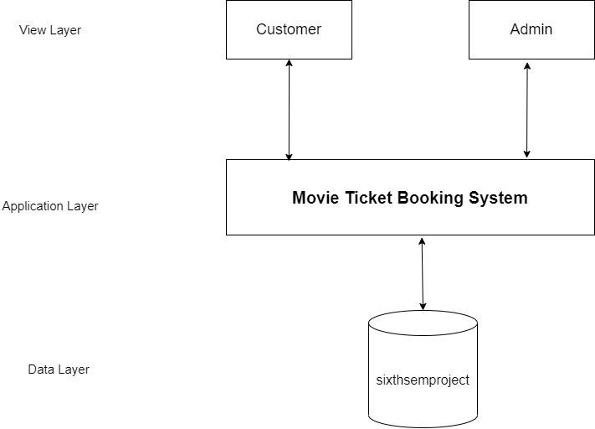

Fig: 3.8 Architecture Design

### **3.2.2 Database Schema Design**

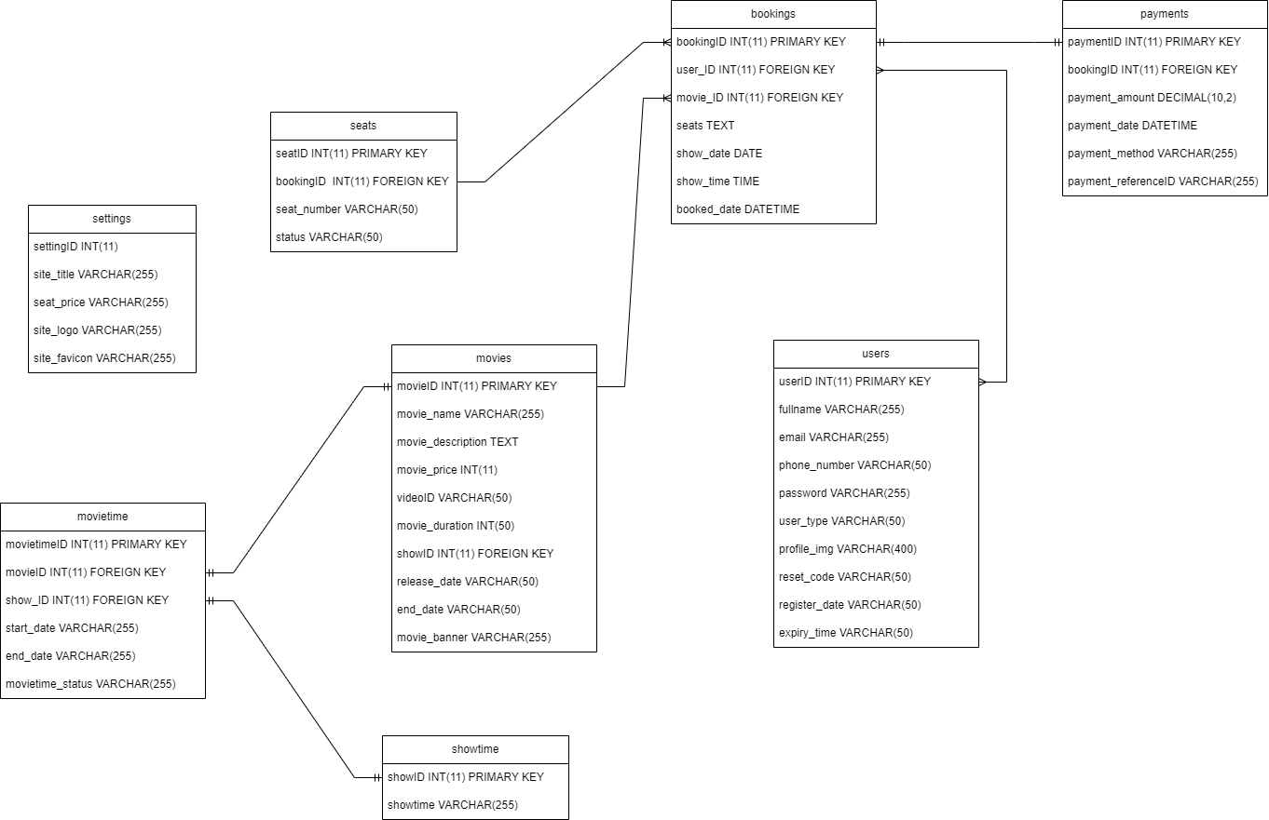

Fig:3.9 Database Schema Design

### **3.2.3 Interface Design**

* Registration Page UI

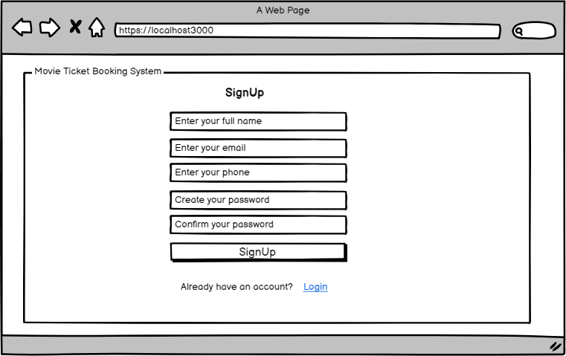

* Login Page UI

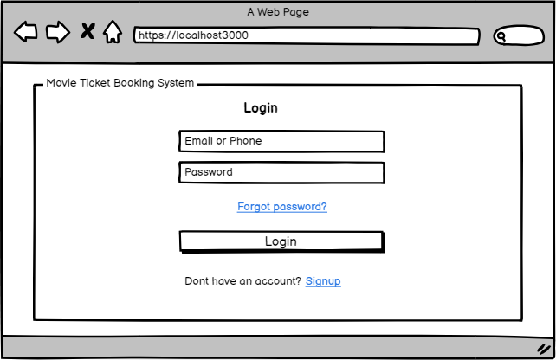

* Home Page UI

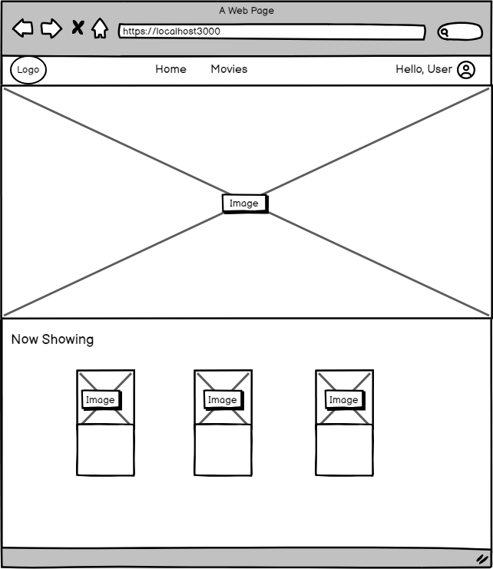

* Dashboard UI

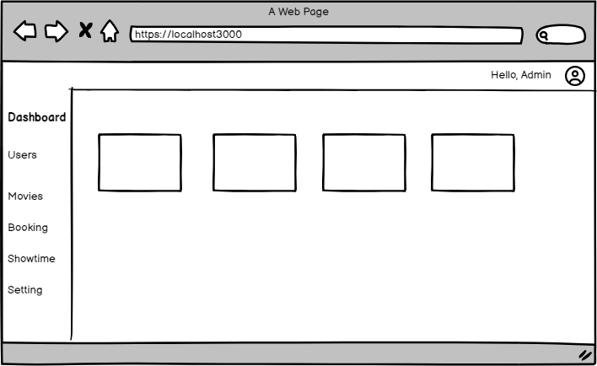

* Add movies

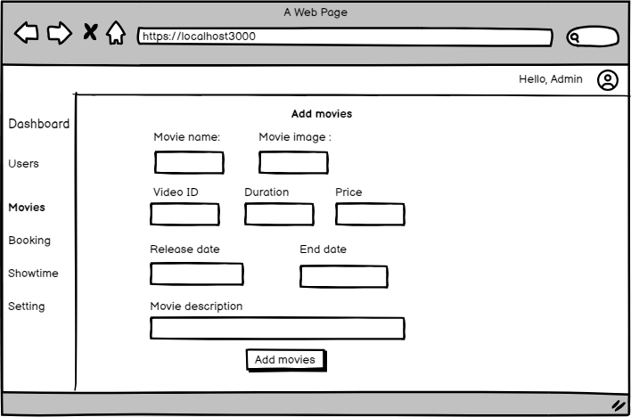

* Booking UI

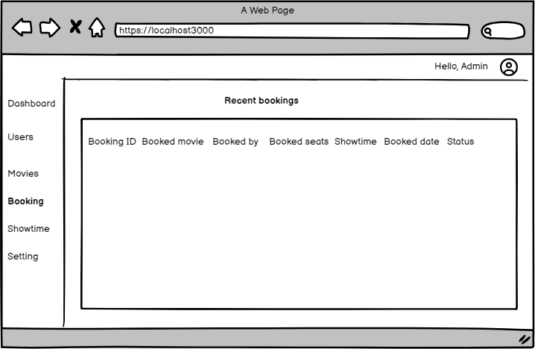

## **3.3 Algorithm Details**

# **Chapter 4: Implementation and Testing**

## **4.1 Implementation**

In this phase, the working of the overall system is checked. It deals with the complete

process of building and implementing it. It focuses on the technical aspects of the

system starting with identifying the necessary components and building the relevant

relationship among subsystems for the smooth and efficient operation of the system.

### **4.1.1 Tools Used**

**Vs code**-It is a streamlined code editor with support for development operations like debugging task running and version control. It supports many programming languages.

**Draw.io**- Draw.io: It is proprietary software for making diagrams and charts. The software lets us choose from an automatic layout. They have a large selection of shapes and hundreds of visual elements to make our diagram or chart one-of-a-kind.

In the proposed system, we used HTML, CSS, and JavaScript to make a user interface. While PHP and MySQL are used to interact with local server I.e localhost and database respectively.

**Client Side**

* HTML

HTML is used for developing user layouts.

* CSS

CSS is used for designing the web pages of the system.

* Javascript

Javascript is used for validating and creating user functionalities.

**Server Side**

* PHP

PHP is used for interaction with local servers i.e. localhost.

* MySQL is used as a database where data are stored and retrieved from.

## **4.1.2 Implementation details of modules**

1. **Customer Module**

* Register to the system
* Login to the system
* Select movie
* Select showtime
* Select seat
* Book ticket
* Payment

1. **Admin Module**

* Login to the system
* Add movie
* Add showtime
* View booking record

## **4.2 Testing**

### **4.2.1 TestCasee for Unit Testing**

**Table 4.1: Test Case 1 - Registration form**

|  |  |  |  |
| --- | --- | --- | --- |
| Symbol no. | Test Cases | Expected Result | Test Result |
| 101 | Enter valid full name, email, phone, password, and confirm password and click submit | User registration successful | successful |

**Table 4.2: Test Case 2 - Login form**

|  |  |  |  |
| --- | --- | --- | --- |
| Symbol no. | Test Cases | Expected Result | Test Result |
| 101 | Enter a valid email and password | The system should display the dashboard | Successful |
| 102 | Invalid email and password | Display error result | Successful |

**Table 4.3: Test Case 3 – Select Movie and Showtime**

|  |  |  |  |
| --- | --- | --- | --- |
| Symbol no | Test Cases | Expect Result | Test Result |
| 101 | Actual time is beyond the showtime | The showtime cant be selected | Successful |

**Table 4.4: Test Case 4 – Book seats**

|  |  |  |  |
| --- | --- | --- | --- |
| Symbol no | Test Cases | Expect Result | Test Result |
| 101 | Book seat | Seat booked successfully | Successful |

**Table 4.5: Test Case 5 – Make Payment**

|  |  |  |  |
| --- | --- | --- | --- |
| Symbol no | Test Cases | Expect Result | Test Result |
| 101 | Choose a payment method | Payment made successfully | Successful |

### **4.2.2 Test Cases for System Testing**

**Table 4.6:**  **Test Scenario 00_01- Login to the system**

|  |  |  |  |  |  |  |
| --- | --- | --- | --- | --- | --- | --- |
| Test Scenario | Test-Case ID | Test Case | Test-Data | Expected Output | Actual Output | Status |
| TC_00_01 | TC_001 | Login | Type URL: login | Redirect to the dashboard if the correct email and password  else reload the same login page | Redirect to the dashboard if the correct email and password  else reload the same login page | Pass |
| TC_002 | Load dashboard | Type URL: dashboard | Dashboard loaded | Dashboard loaded | Pass |

**Table 4.7:**  **Test Scenario 00_02- Adding movies**

|  |  |  |  |  |  |  |
| --- | --- | --- | --- | --- | --- | --- |
| Test Scenario | Test-Case ID | Test Case | Test-Data | Expected Output | Actual Output | Status |
| TC_00_02 | TC_001 | Add movies | Click a link: Add | Movies are added based on information provided by Admin. | New movies will be added and the user can book the room of his choice | True |
|  | TC_002 | Again add the movie but without filling in the fields | Click a link: Add | Message: You must fill in all the field | Message: You must fill in all the field | True |

# **Chapter 5: Conclusion and Future Recommendation**

## **5.1 Conclusion**

With the help of this project opportunity, we gained real-world experience in web development and system development. In the completion of this project, we felt that this project was very beneficial in terms of experience and skill development. Some of the practical knowledge we have learned can be pointed out as follows.

* Bringing ideas into implementation
* Importance of time management and schedule working and how it can improve the outcome
* Importance of teamwork and communication to coordinate tasks completely, effectively, and efficiently.

## **5.2 Outcome**

The movie ticket booking system has greatly enhanced the cinema-going experience. It has simplified the booking process and provided moviegoers with the convenience of booking their seats from the comfort of their homes.

## **5.3 Future Enhancements**

* We can assign QR codes to the tickets.
* We can add more Halls to show different movies at a time.

# **References**

# **References**

|  |  |
| --- | --- |
| [1] | Mihai Balan, "GPRS-Based Cinema Ticket Reservation System," Kongens Lyngby, Denmark, August 2007.  http://www2.imm.dtu.dk/pubdb/edoc/imm5403.pdf |
| [2] | V. Guasch, "Contributions to the Security and Privacy of Electronic Ticketing Systems," Tarragona, Spain, May 15, 2013.  https://www.tdx.cat/handle/10803/119683 |
| [3] | V. Gupta, "Dynamic Pricing in Movies Tickets Using Regression Technique," IEEE, Bhopal, India, December 2018.  ieeexplore.ieee.org/abstract/document/8933733/ |